

**Gulf Aluminium Rolling Mill B.S.C. (closed)**

Visitor Pass System

**User Guide Manual**

**Prepared by:**

Ervin Brosas

ICT Department

*Ext. No: 3152*

Table of Contents

How to Create New Visitor Pass Record? 3

How to Block a Visitor? 5

How to Search for Specific Visitor and Print the Visit Log Report? 8

## How to Create New Visitor Pass Record?

1. Open the new Time & Attendance System by entering this URL address in the Internet Explorer browser: <http://tasportal>. In the Homepage screen, go to Security Module => Visitor Pass menu then click the “**Visitor Entry**” link to open the Visitor’s Pass Entry screen as shown in the following screenshots.

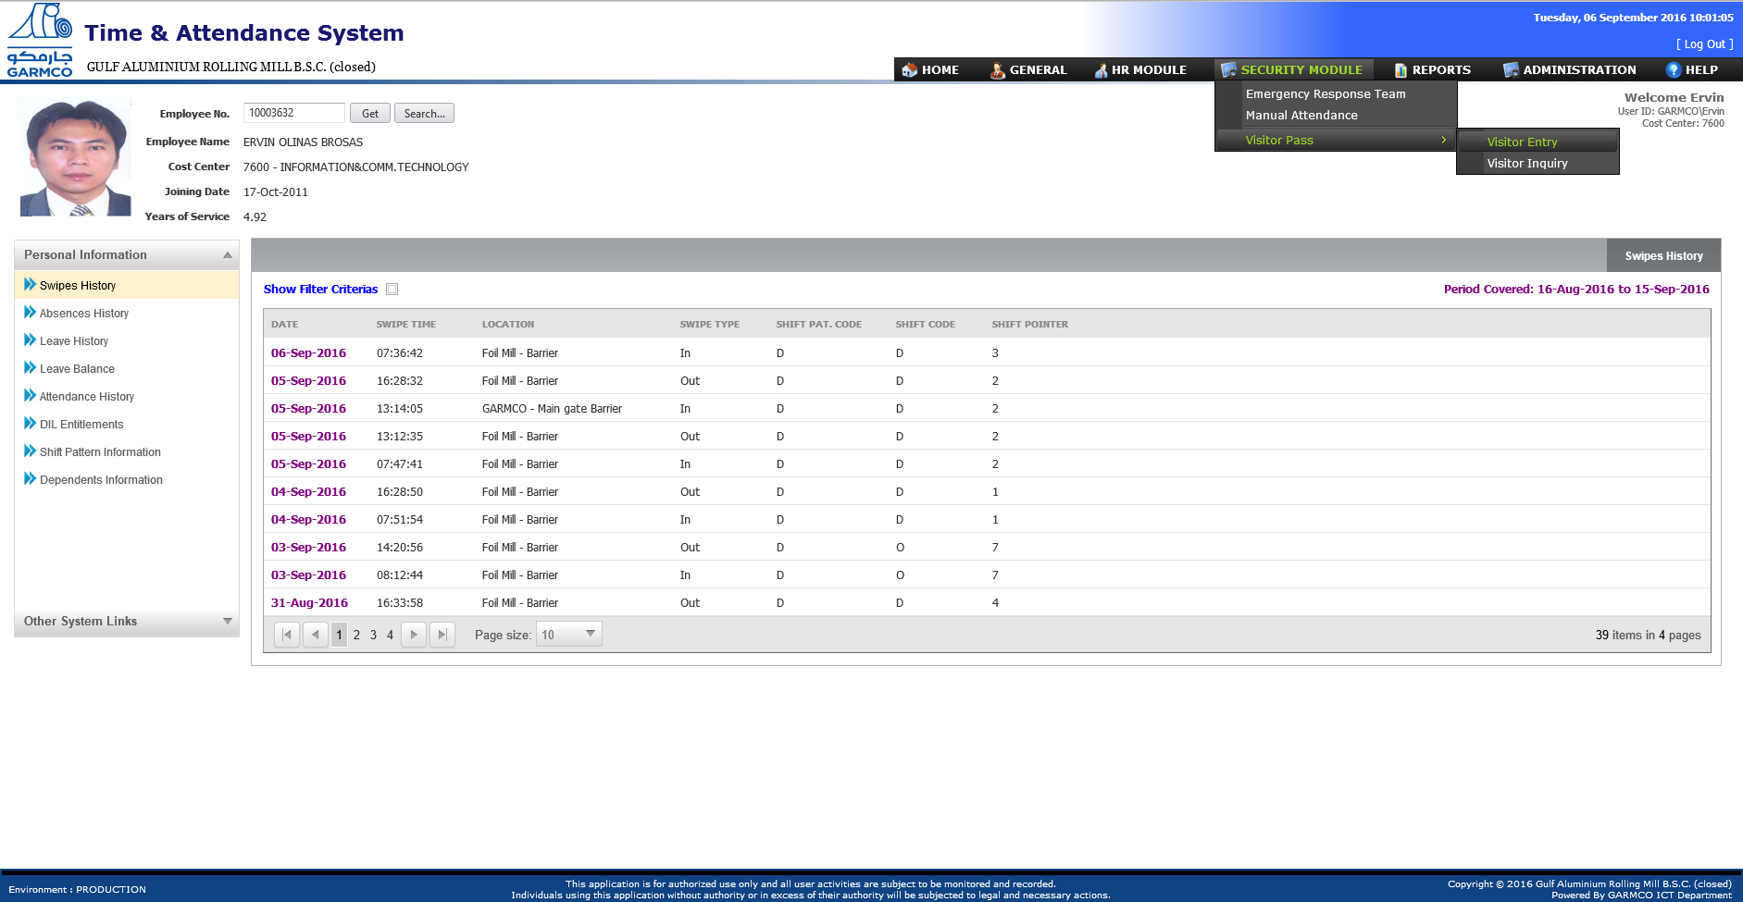

**2**

**1**

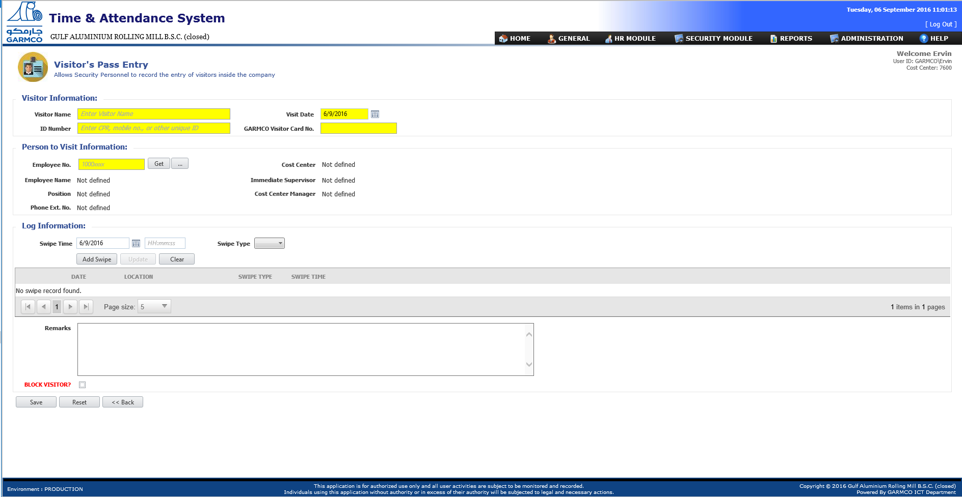

1. To create a new record follow the below procedures:
   1. Enter the Visitor Name
   2. Specifiy the Visit Date
   3. Enter the ID Number which can be any of the following: CPR, passport number or mobile number
   4. Enter the Visitor Card number which is written in the ID badge given by the Security personnel
   5. Enter the employee no. of the person to be visited then click the **Get** button.
   6. Specify the swipe date and time, select whether In or Out then click the **Add** button. *(Note: This is optional since the swipe time can be fetched from the readers once the visitor swipes his/her ID badge).*
   7. Provide the Remarks *(Note: This field is optional only)*
   8. Click the **Save** button to save data in the database.

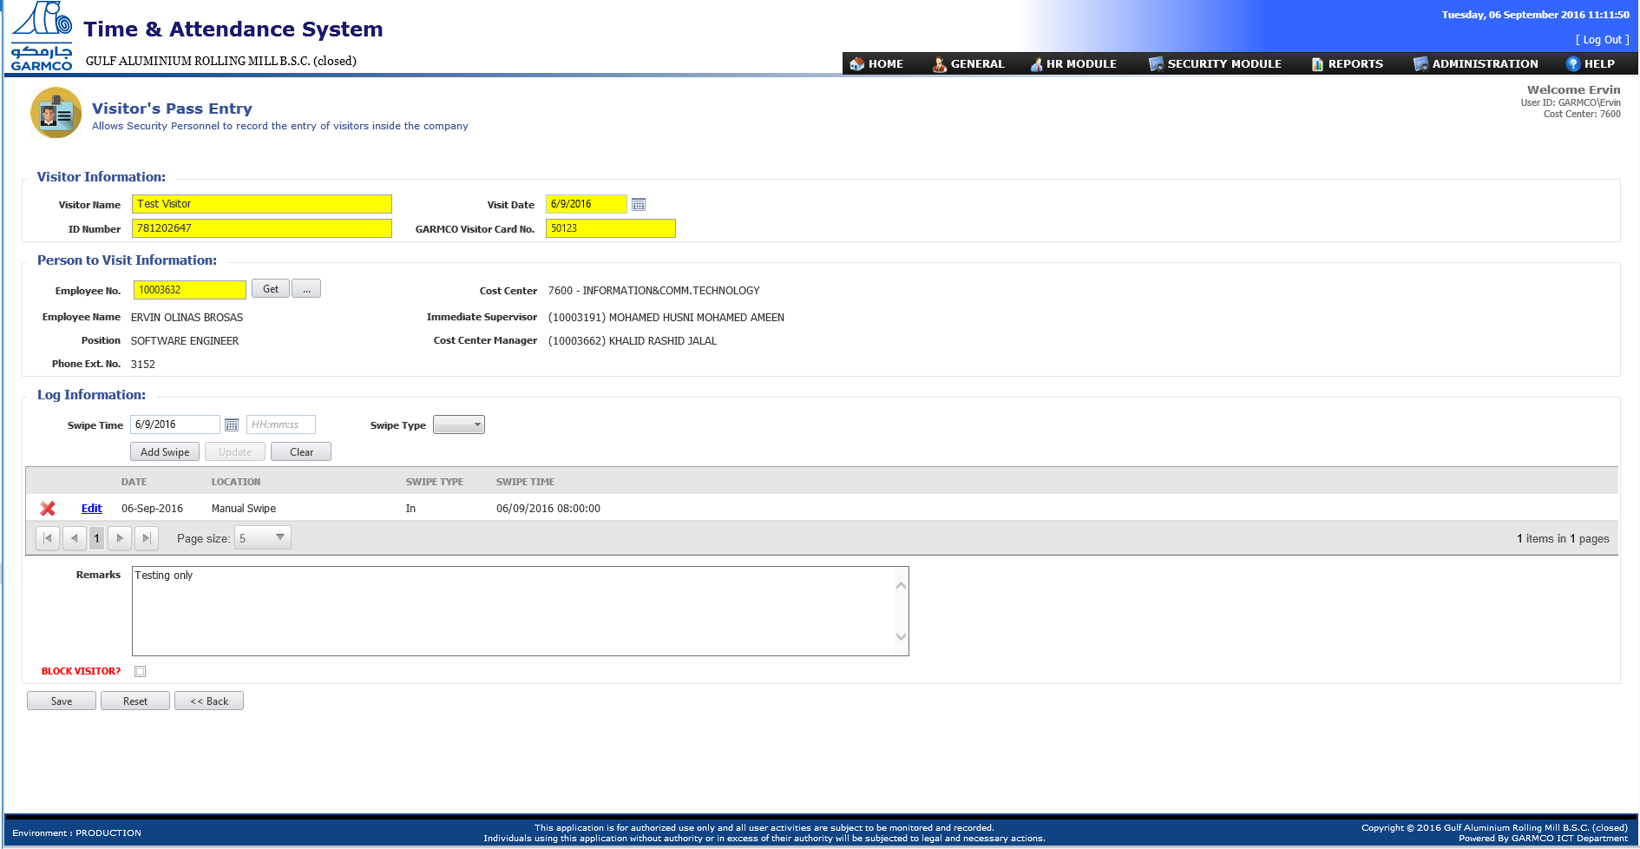

**8**

**7**

**6**

**5**

**2**

**4**

**3**

**1**

## How to Block a Visitor?

1. Open the new Time & Attendance System by entering this URL address in the Internet Explorer browser: <http://tasportal>. In the Homepage screen, go to Security Module => Visitor Pass menu then click the “**Visitor Inquiry**” link to open the Visitor Pass Inquiry screen as shown in the following screenshots.

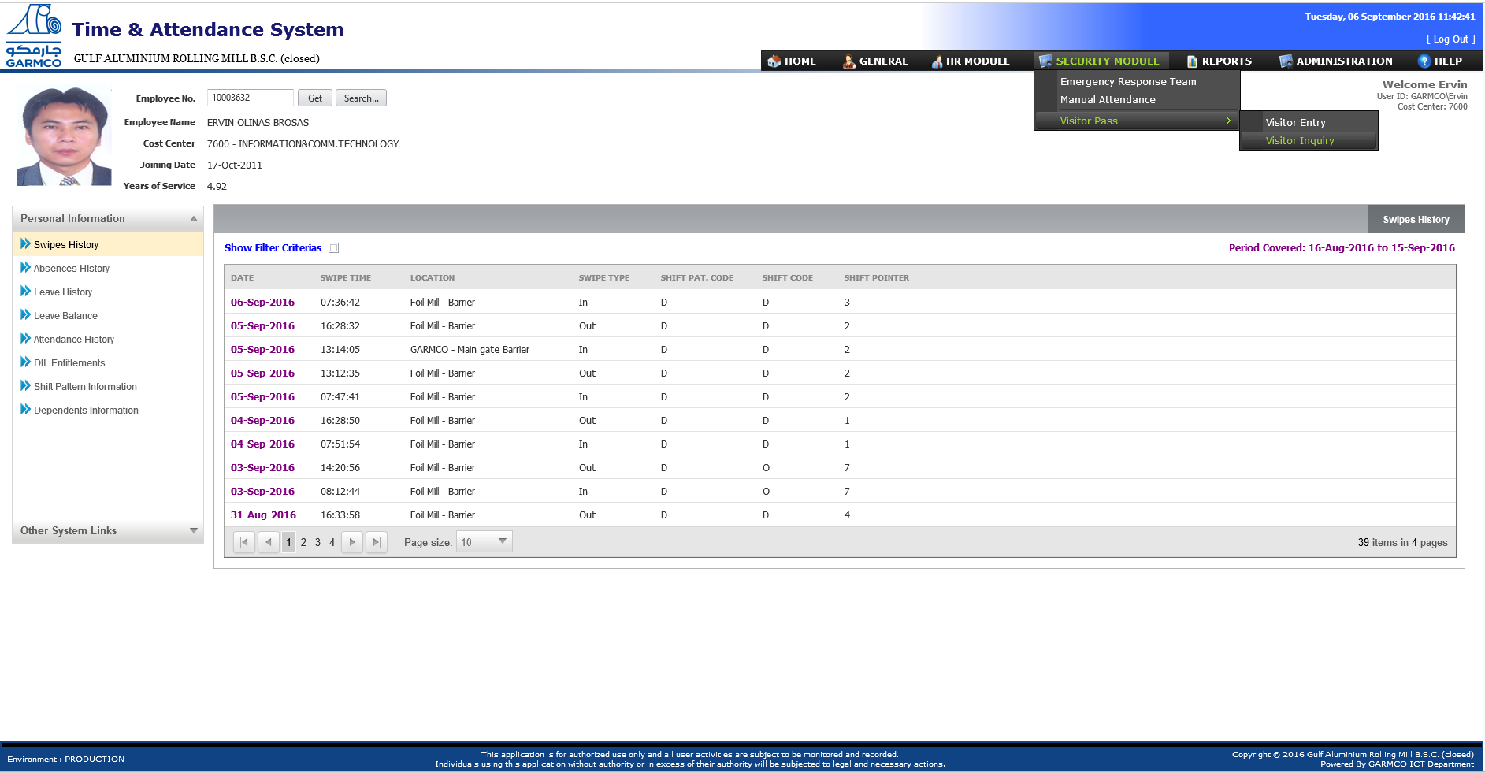

**1**

**2**

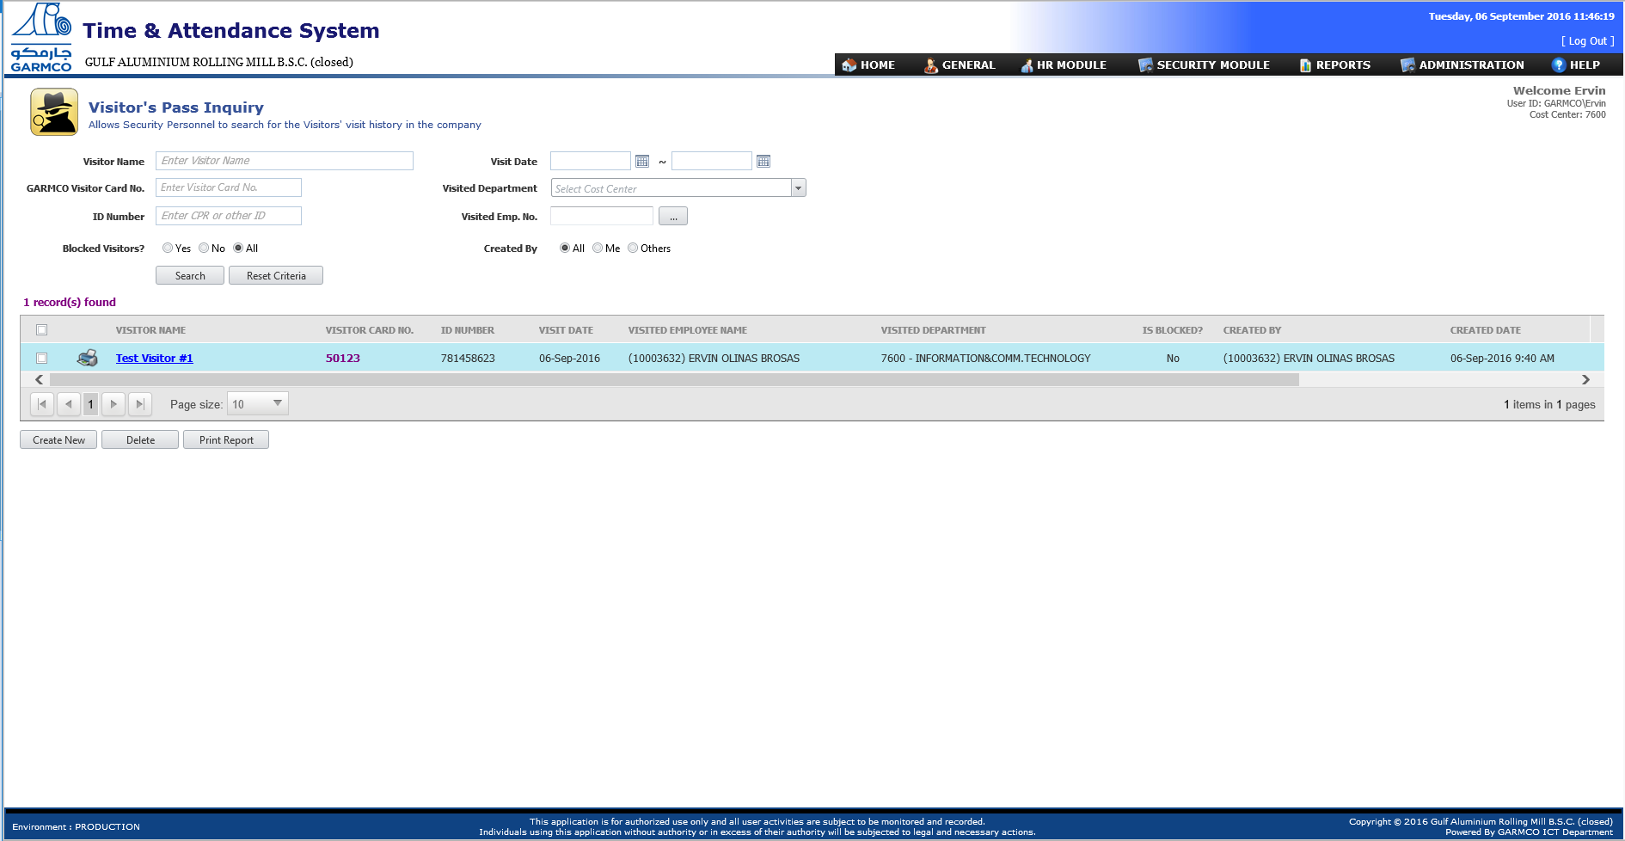

1. To block a visitor follow the below procedures:
2. Search for the desired visitor using the **Visitor’s Pass Inquiry** form. Enter data in the filter criteria fields to fine tuned the search results.
3. If the desired visitor is found, click the visitor name in the grid.
4. The visitor’s visit information will be shown in the next screen. Tick the **Block Visitor** checkbox.
5. Click **Save** button to save the data. The Visitor’s Pass Inquiry page will be shown with the record highlighted in red color background.

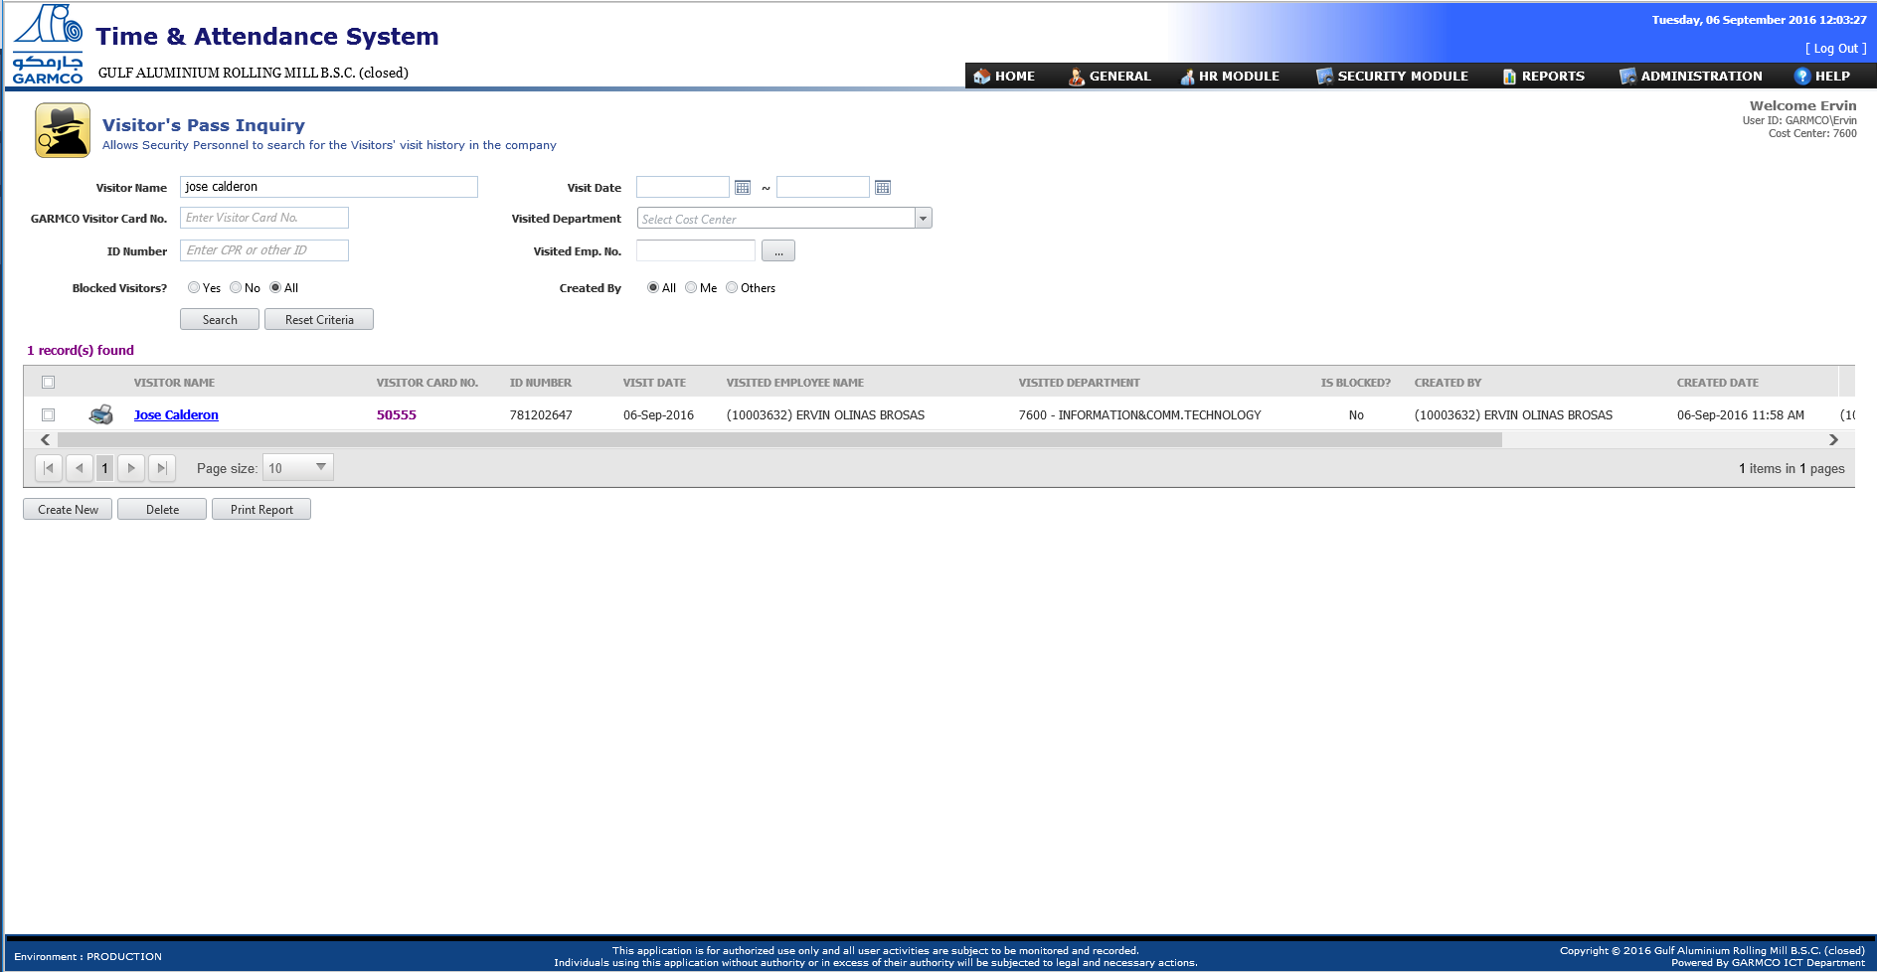

**2**

**1**

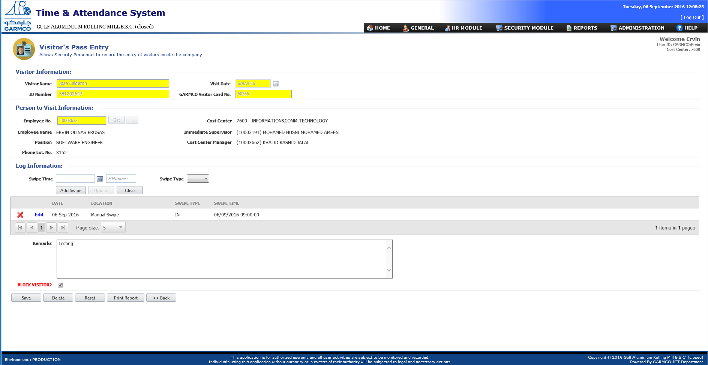

**4**

**3**

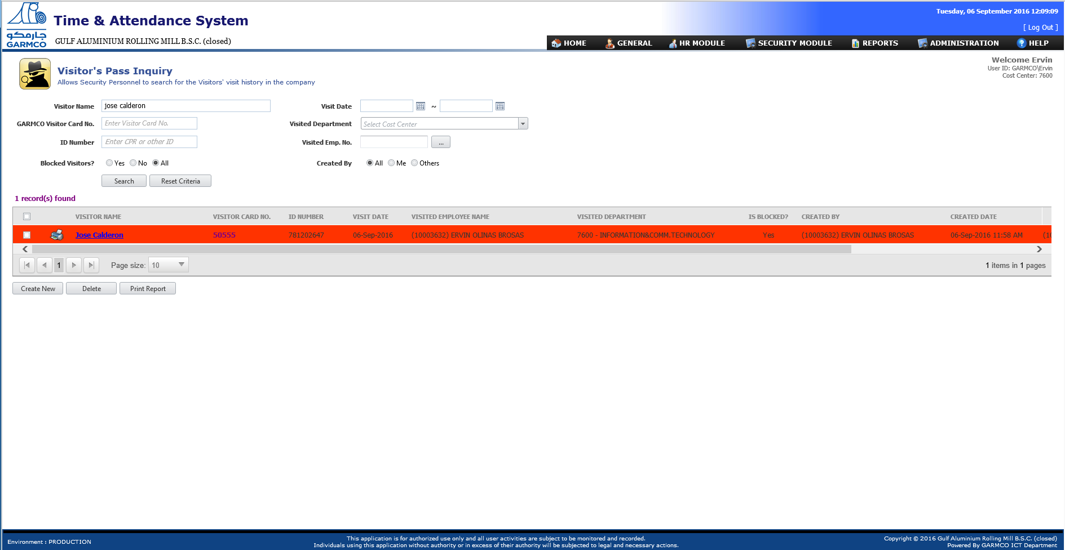

## How to Search for Specific Visitor and Print the Visit Log Report?

1. Open the new Time & Attendance System by entering this URL address in the Internet Explorer browser: <http://tasportal>. In the Homepage screen, go to Security Module => Visitor Pass menu then click the “**Visitor Inquiry**” link to open the Visitor Pass Inquiry screen as shown in the following screenshots.



**1**

**2**

1. To search for specific visitor and print the visit log report, follow the below procedures:
2. Supply the information in the search filter criteria section and then click the **Search** button.
3. If the desired visitor is found, click the printer icon in the grid which is found beside the visitor name.
4. The visitor’s visit information will be shown in the next screen. Tick the **Block Visitor** checkbox.
5. Click **Save** button to save the data. The Visitor’s Pass Inquiry page will be shown with the record highlighted in red color background.



**2**

**1**

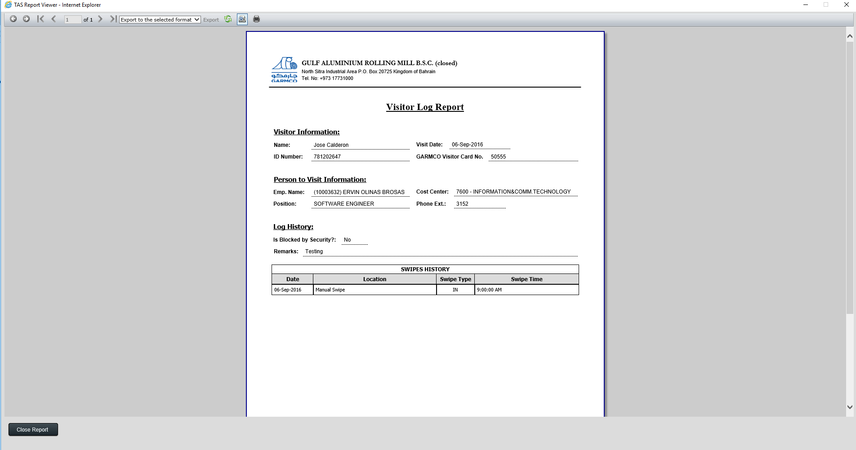

1. To export the report into other format such as PDF, Excel, CSV, etc. follow the below procedures.
   1. Select the desired target format from the drop-down list.
   2. Click the **Export** link.
   3. A pop-up form will come out at the bottom part of the screen, click **Open** to open the file or **Save** to save the file into the harddrive.

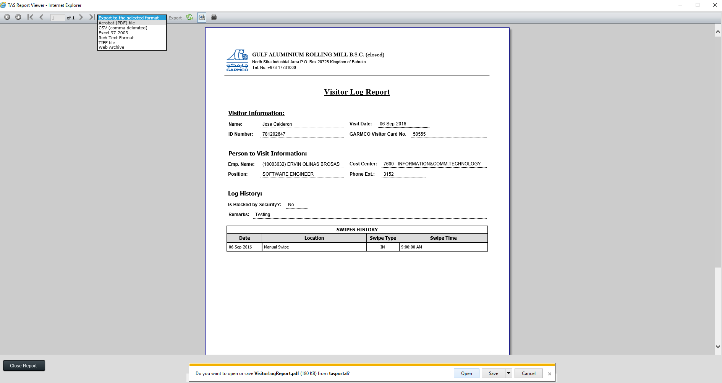

**3**

**2**

**1**